The demand for flexible and career-focused education is growing rapidly across India, especially in metropolitan areas like Sherpur. Working professionals, entrepreneurs, fresh graduates, and business aspirants are now choosing online education to improve their qualifications without affecting their work schedules. Among all professional programs, the Online MBA has become one of the most preferred choices because it combines management knowledge, leadership skills, business understanding, and career growth opportunities in one program.
An Online MBA in Sherpur is ideal for students and professionals who want quality education with flexibility. The program allows learners to study from anywhere while managing work, business, internships, or personal responsibilities. Unlike traditional classroom education, online MBA programs provide recorded lectures, live sessions, digital study materials, online examinations, and interactive learning platforms that make education more accessible and convenient.
Today, companies are looking for professionals who understand business operations, marketing, finance, human resources, analytics, and strategic decision-making. An online MBA helps students build these industry-relevant skills while saving travel time and additional expenses. With the rise of digital businesses, startups, e-commerce, and remote working environments, the value of online management education has increased significantly.
Vidyarishi India is helping students and professionals achieve their career goals through recognized and industry-oriented online degree programs. Through partnerships with leading universities and institutions, Vidyarishi India provides guidance, admission support, counseling, and career-focused education solutions that help learners choose the right path for their future.



What is an Online MBA?
An Online MBA is a postgraduate management degree that can be completed through digital learning platforms. The program focuses on business administration, management practices, leadership development, strategic planning, and industry specialization. Students can attend live lectures, access recorded classes, complete assignments online, and appear for examinations remotely.
The structure of an online MBA is designed to provide the same academic value and industry exposure as traditional MBA programs. Universities offering online MBA programs follow updated curriculums that align with current market trends and business requirements.
Online MBA programs are suitable for:
- Working professionals
- Business owners
- Entrepreneurs
- Fresh graduates
- Freelancers
- Corporate employees
- Individuals looking for career growth
The flexibility of online learning allows students to continue their education without leaving their jobs or relocating to another city.

Benefits of Online MBA
One of the biggest reasons students choose an Online MBA in Sherpur is flexibility. Students can attend classes according to their schedules and study at their own pace. This helps professionals maintain work-life balance while upgrading their qualifications.
Another major benefit is affordability. Online MBA programs are generally more cost-effective than regular full-time MBA programs. Students can save money on travel, accommodation, relocation, and campus expenses.
Online MBA programs also provide access to advanced digital learning tools. Students can revisit recorded lectures multiple times, participate in online discussions, access e-books, and interact with faculty members through virtual platforms.
Career growth is another important advantage. Many professionals pursue online MBA programs to qualify for managerial positions, salary increments, promotions, and leadership opportunities within organizations.
The program also improves communication skills, problem-solving abilities, analytical thinking, leadership qualities, and decision-making skills. These abilities are highly valued across industries including IT, finance, healthcare, retail, marketing, logistics, banking, consulting, and e-commerce.

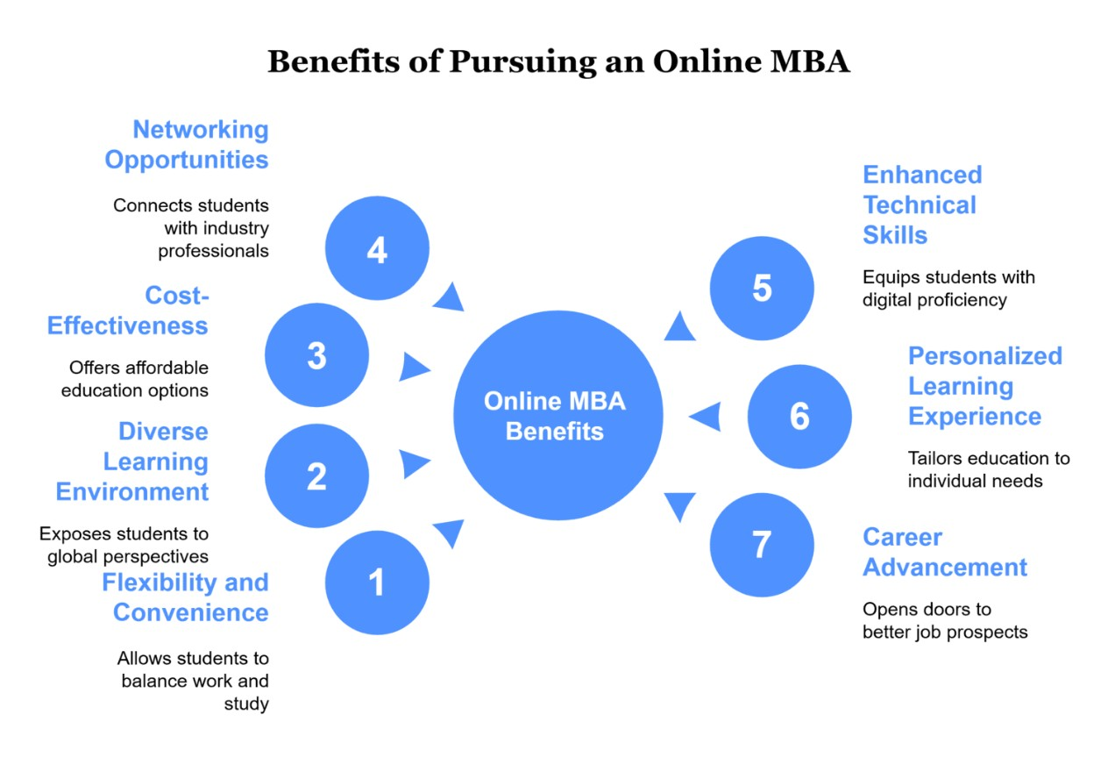

Advantages of Online MBA
An Online MBA offers several long-term advantages for students and professionals who want to remain competitive in the modern business world. The program allows learners to gain industry exposure while continuing their professional journey.
Students can apply practical business concepts directly to their jobs, making learning more effective and experience-oriented. Online MBA programs also encourage self-discipline, time management, and independent learning skills.
The digital format makes education accessible from any location. Whether students are living in Sherpur or working in another city, they can continue their studies without interruption.
Some key advantages include:
- Flexible study schedule
- Learn while earning
- Lower educational costs
- Industry-relevant curriculum
- Career advancement opportunities
- Global learning exposure
- Improved leadership and management skills
- Better networking opportunities
- Access to digital learning resources
The increasing acceptance of online degrees by employers has further strengthened the value of online MBA programs in India and internationally.

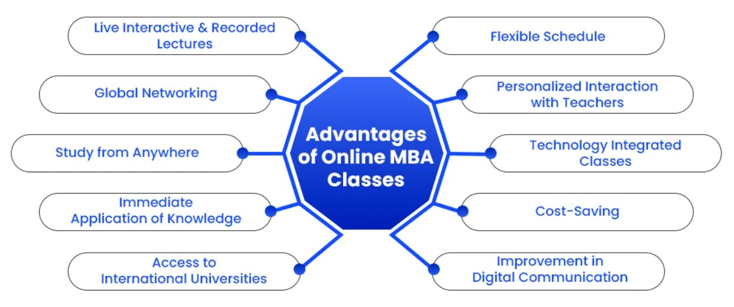

Online MBA Specializations and Courses
Online MBA programs offer multiple specializations that help students build expertise in specific business domains. Choosing the right specialization depends on career goals, interests, and industry demand.
Online MBA in Marketing Management
Marketing Management focuses on branding, advertising, digital marketing, consumer behavior, sales strategies, and market research. This specialization is suitable for students interested in creative business roles and brand development.
Online MBA in Finance Management
Finance Management helps students understand investment strategies, accounting, taxation, financial planning, banking operations, and risk management. It is one of the most popular MBA specializations because of its strong career opportunities.
Online MBA in Human Resource Management
Human Resource Management focuses on recruitment, employee engagement, training, payroll management, labor laws, and organizational behavior. HR professionals play a vital role in workforce management and company culture.
Online MBA in Business Analytics
Business Analytics combines management with data-driven decision-making. Students learn analytics tools, business intelligence, data interpretation, and performance analysis that help companies improve operational efficiency.
Online MBA in Operations Management
Operations Management focuses on supply chain management, logistics, production planning, inventory control, and operational efficiency. This specialization is ideal for manufacturing, retail, and logistics industries.
Online MBA in Information Technology Management
IT Management combines business administration with technology management. Students learn about software systems, IT infrastructure, project management, cybersecurity, and digital transformation strategies.
Online MBA in Healthcare Management
Healthcare Management prepares students for administrative and management roles in hospitals, healthcare institutions, pharmaceuticals, and medical organizations.
Online MBA in International Business
International Business focuses on global trade, export-import management, international marketing, foreign policies, and cross-border business operations.
Online MBA in Retail Management
Retail Management helps students understand customer experience, merchandising, inventory planning, retail operations, and sales management.
Online MBA in Entrepreneurship
Entrepreneurship specialization is designed for individuals who want to start or manage their own businesses. Students learn startup management, innovation, business strategy, funding, and business development.



Salary After Online MBA
One of the major reasons students pursue an Online MBA in Sherpur is better salary opportunities. MBA graduates are often preferred for leadership, strategic, and managerial roles across industries.
Salary packages depend on factors such as specialization, work experience, company profile, industry, communication skills, and job location.
Fresh graduates with an online MBA can expect entry-level management opportunities in sectors like marketing, finance, HR, operations, customer relationship management, and business development.
Experienced professionals often pursue online MBA programs to secure promotions and higher managerial responsibilities. Mid-level and senior professionals can achieve significant salary growth after completing their MBA.
Approximate salary expectations include:
- Entry-level professionals: ₹3 LPA – ₹6 LPA
- Mid-level professionals: ₹6 LPA – ₹12 LPA
- Senior management professionals: ₹12 LPA – ₹25 LPA+
Specializations such as Business Analytics, Finance, IT Management, and Digital Marketing often offer strong salary potential due to increasing industry demand.

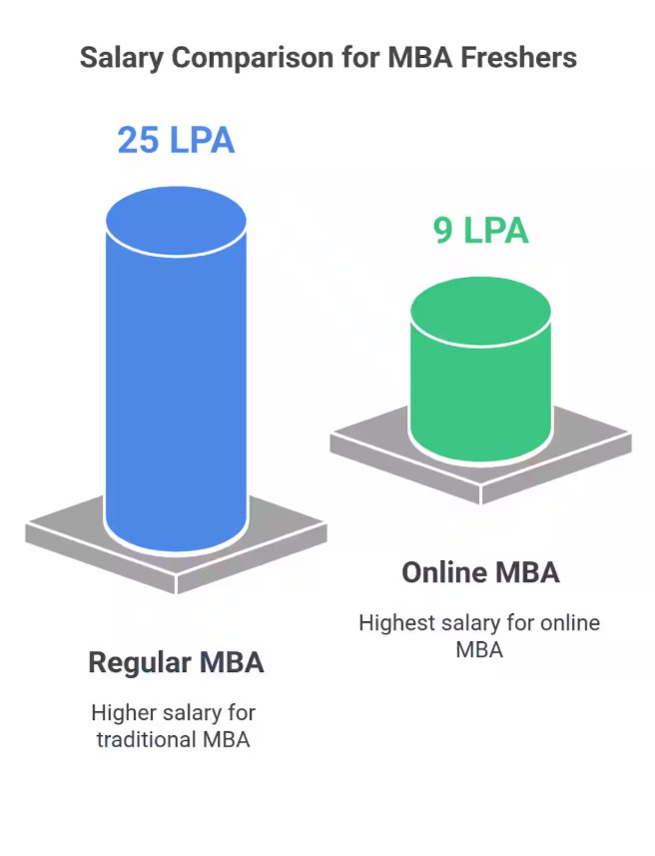

Career Opportunities After Online MBA
An Online MBA opens doors to multiple career opportunities across industries. Companies require professionals who can manage teams, handle operations, improve business performance, and lead organizational growth.
MBA graduates can work in industries such as:
- Information Technology
- Banking and Finance
- Healthcare
- Retail
- Digital Marketing
- E-commerce
- Consulting
- Education
- Logistics
- Manufacturing
- Media and Advertising
Popular job roles after an online MBA include Business Manager, Marketing Manager, HR Manager, Financial Analyst, Operations Manager, Business Analyst, Project Manager, Product Manager, Sales Manager, and Entrepreneur.
The growing startup ecosystem in India has also increased demand for MBA graduates who can handle business strategy, scaling operations, and team leadership.



Scope of Online MBA in India
The future scope of Online MBA programs in India is growing rapidly due to digital transformation and changing educational trends. Companies are now focusing more on skills, practical knowledge, leadership abilities, and business understanding rather than only traditional classroom education.
The rise of remote work, online businesses, and technology-driven industries has increased the demand for professionals with management expertise. Online MBA graduates are finding opportunities in multinational corporations, startups, government projects, consulting firms, and global organizations.
With improved recognition of online degrees from reputed universities, students can pursue higher education and career growth simultaneously. The online learning ecosystem in India is expected to expand further, making online MBA programs even more valuable in the future.

Vidyarishi India Online Courses
Vidyarishi India provides career-oriented online education programs designed to support students and working professionals. The platform helps learners choose suitable programs based on their career goals, educational background, and industry interests.
Vidyarishi India offers guidance for multiple online and distance learning programs including:
- Online MBA
- Online BBA
- Online MCA
- Online BCA
- Online MCom
- Online BCom
- Online BA
- Online MA
- Online DBA
- Professional Certification Programs
The programs are designed to provide flexibility, accessibility, and industry-relevant knowledge to learners across India.

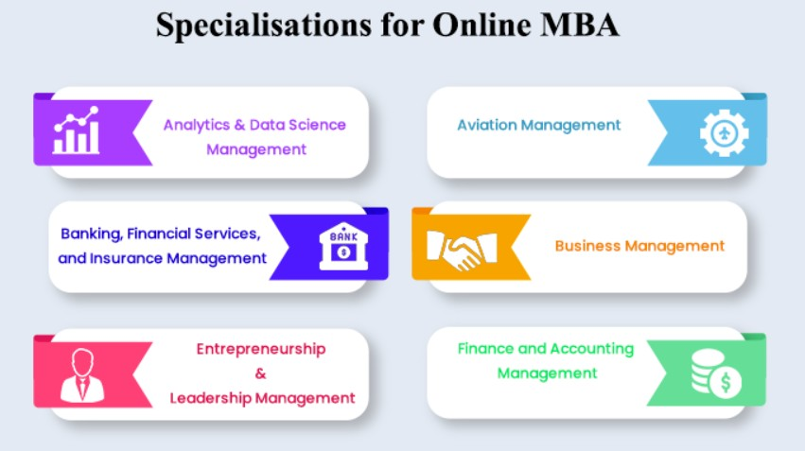

About Vidyarishi India
Vidyarishi India Official Website is an educational platform focused on helping students access quality online and distance education programs from recognized universities and institutions. The organization supports learners through career counseling, admission assistance, university selection guidance, and academic support services.
Vidyarishi India believes in making higher education accessible and flexible for students who want to continue learning while managing work and personal responsibilities. The platform aims to bridge the gap between students and quality education opportunities through technology-driven learning solutions.
The institution focuses on student growth, career development, skill enhancement, and professional success through industry-oriented educational programs.

Vidyarishi India University Partners
Vidyarishi India collaborates with recognized universities and educational institutions to provide trusted and accredited online programs. These partnerships help students access high-quality education, updated curriculums, expert faculty support, and recognized degrees.
Partner universities focus on practical learning, digital education infrastructure, academic excellence, and career-oriented programs that meet industry standards.
Students can receive support for admissions, counseling, specialization selection, and program understanding through Vidyarishi India’s educational guidance system.

Discover Your Perfect Education Partner
Choosing the right educational partner is an important step in building a successful career. Students should consider factors such as university recognition, course curriculum, flexibility, specialization options, placement support, affordability, and learning resources before selecting an online MBA program.
Vidyarishi India helps students discover programs that match their career goals and future aspirations. Whether someone wants career advancement, salary growth, entrepreneurship opportunities, or skill development, the right online MBA program can create long-term professional value.
The organization supports students throughout their educational journey by providing reliable information, admission assistance, and guidance for selecting the best online degree programs.

Contact Vidyarishi India
Students interested in Online MBA admissions and career guidance can connect with Vidyarishi India for personalized counseling and course information.
Contact Details
🌐 Website: Vidyarishi India Website
📞 Contact Number: +91 91525 35535
Students can explore different online MBA specializations, admission procedures, eligibility criteria, fee structures, and career opportunities through the official platform.

Conclusion
An Online MBA in Sherpur has become an excellent option for students and professionals who want flexible, affordable, and career-focused education. The program provides valuable business knowledge, leadership skills, industry exposure, and specialization opportunities that help individuals achieve long-term professional success.
With growing acceptance of online education and increasing demand for management professionals, an online MBA offers strong career potential across industries. Whether someone wants a promotion, salary growth, entrepreneurial success, or managerial expertise, the program can support multiple career goals.
Vidyarishi India continues to support students through trusted online education programs, expert guidance, university partnerships, and career-focused learning opportunities. By choosing the right specialization and educational platform, students can build a successful future in the competitive business world.

